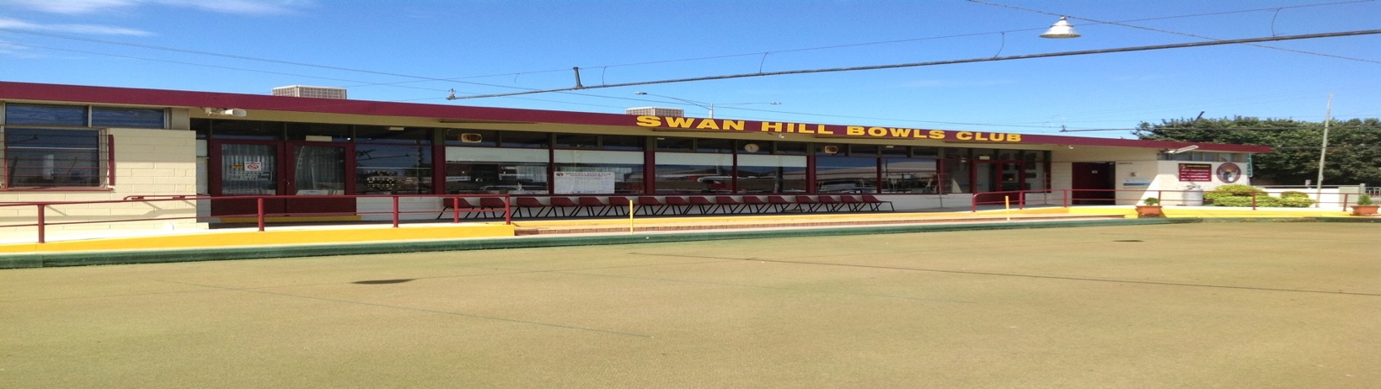

SWAN HILL BOWLS CLUB
Classic on the Murray
Two Bowl Triples
Wednesday & Thursday

21^{R} - 22TH February 2024
9.30 Start
$180 per Team Entry
Prize Money
$4500.00
1st $1500, 2nd $1050
3rd $600, 4th $300

$180 Money back for Best Winning
Score in Each Round.
Not a Prize Winner

Entries Close- Monday 20th February 2024 Contact Mick Balchin 0428 553 913 Email:- bowlssh@bigpond.com

